Linked Queue
Implement a queue by a "doubly-linked list" as underlying data structure:
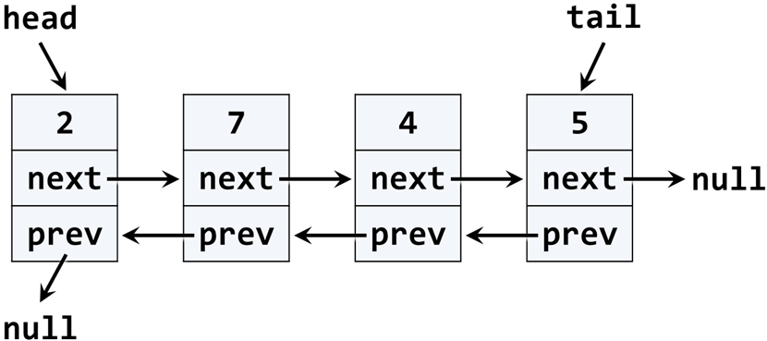
Use the following code as start:
public class LinkedQueue<T>
{
public int Count { get; private set; }
public void Enqueue(T element) { … }
public T Dequeue() { … }
public T[] ToArray() { … }

private class QueueNode<T>
{
public T Value { get; private set; }
public QueueNode<T> NextNode { get; set; }
public QueueNode<T> PrevNode { get; set; }
}
}
You may modify and adjust the code from the DoublyLinkedList<T> class from the last lesson. If the queue is empty, the Dequeue() should throw InvalidOperationException.

